November 2009

THNS Forum, Shanghai 11th-12th November 2009
Freight Villages and Urban Planning: a Sino-French Approach

Michel Savy
professor, University of Paris-East
codirector, Sino-French Centre for Urban and Regional Planning Studies
savy@univ-paris12.fr
&
Liu Xiaoming
PhD student, University of Paris-East
liuxiaomingdl@yahoo.fr

Logistics is a key function in economic development, for production and for distribution; it gives birth to an emerging new industry. Logistics is also a key factor of spatial functioning and organisation, requiring an adequate attention and priority in planning. A comparison of Chinese and French experiences dealing with "freight villages" throws light on the major stakes and questions of introducing logistics into urban and regional planning agenda.

- Logistics, territory and the city

Logistics is often defined according to its generic aims ("to put at disposal the proper good, in proper condition, at the right place and the right time, at lowest cost"), which is not a substantive definition. From an abundant literature, two families of senses emerge.
On the one hand, logistics names a series of physical operations, applied to goods in complement to other operations pertaining to manufacturing: transport, warehousing, handling, packaging, picking and packing. These operations are production operations; they transform goods by changing their position in space and time, making them available for a suitable use. The frontier with manufacturing is sometimes blurred, when logistics operations are mixed with postponed customisation of products or with repair of durable goods.
On the other hand, logistics names a method of running a firm and relationships between firms (supply chain management). Logistics is a function in an organisation, relying on specific tools for flows monitoring and control, it has become a branch of management science besides finance, marketing, etc.
In addition, logistics is now the name of an emerging industry, the logistics service industry where third party logistics providers (3PL) operate. In this context, the real estate part of logistics activities has gained a growing autonomy (neither logistics service providers nor their customers wishing to own logistics facilities any more) and becomes per se a stake for spatial planning.

Just as transport (which it comprises), logistics is essentially a spatial activity and its aim is to link geographically separated activities (for production or consumption). Transport haulage on the one hand, freight terminals on the other hand (warehouses, depots, sorting facilities, etc.) are the arches and nodes of logistics networks. They are neither randomly nor uniformly located on territory, at various scales (according to the type of flows they operate: intercontinental, continental, regional or local). The tendency is a growing polarisation of logistics activities facilities in certain regions and, inside regions, in certain sites. Polarisation of logistics depends on the type of goods (from high tech spear parts to grocery) but obeys generic mechanisms which economic geography identifies: economies of scale in production and inventory and decline of transport and other transfer costs.
Main logistics poles coincide with metropolitan areas, because they thus benefit from an access to an important local market for logistics services (emission or reception, distribution), are close to nodes of trunk lines of infrastructure networks, can mobilise a sufficient labour market (crucial for a labour intensive industry), and include their facilities in a broad and active real estate market (flexibility). Urban logistics is not a specific, isolated issue. It is an element of a comprehensive, multi-scale, territorial organisation. But it deserves a special attention, as one notices that most flows of goods nowadays start from or arrive into an urban area. Logistics is a part of the urban system, and requires adapted solutions in an urban context.

Warehousing Areas in French provinces

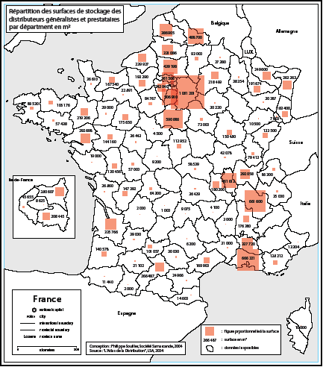

Though, logistics has long been neglected in urban planning and management studies and policies (most attention being given to passenger transport, either public or by private car). It nevertheless is a crucial function for economic activity of the city as well as for everyday life of its inhabitants: urban freight represents about 20 % of urban traffic (in terms of v.km), 30 % of street occupancy and up to 50 % of energy consumption and pollution of urban transport as a whole.
This ignorance is no longer valid: e.g., "logistics" is one of the 10 key-words put forward at the entrance of the recent exhibition "10 projects for the greater Paris". All major Chinese cities elaborate projects to include freight terminals into their urban planning. Compared with logistics facilities located in industrial or rural environments, urban logistics shows strong specificities as it must come to a compromise with the scarcity and fragility of space and with a dense neighbour population. Technically, the issue of "the last mile" (i.e. the conditions in which final delivery can be made) often influences the entire transport chain of the goods, particularly the choice of the mode of transport (road, rail, etc.).
From an urban viewpoint, two opposite risks must be avoided. One is to allow logistics to locate anywhere without sufficient control, scattered within the city without regard for neighbourhood, environment, safety, traffic conditions, etc. The other one is to expel logistics out of the city, due to political pressure or to high land prices. Peripheral location of logistics makes the comprehensive urban activity and urban consumption more difficult and costly, lengthening pick-up and delivery transport legs and augmenting pollution and traffic. According to adequate trade-offs between advantages and drawbacks, a room for logistics must be made in urban master plans.
For the moment being, both dangers exist. Whereas a significant proportion of logistics facilities still locate in a dispersed way, without special care for their environment (assuming they fulfil minimal building and safety regulations), a growing number of them are grouped in dedicated "freight villages", but further and further away in the outskirts of the city. Urban sprawl also comprises logistics sprawl. The following map shows that, from 1980 to 2004, warehouse building took place in more and more remote periphery of the Paris metropolitan area. The same remark applies to the Beijing case.

Warehouse building permits, 1980-2004, Paris metropolitan area

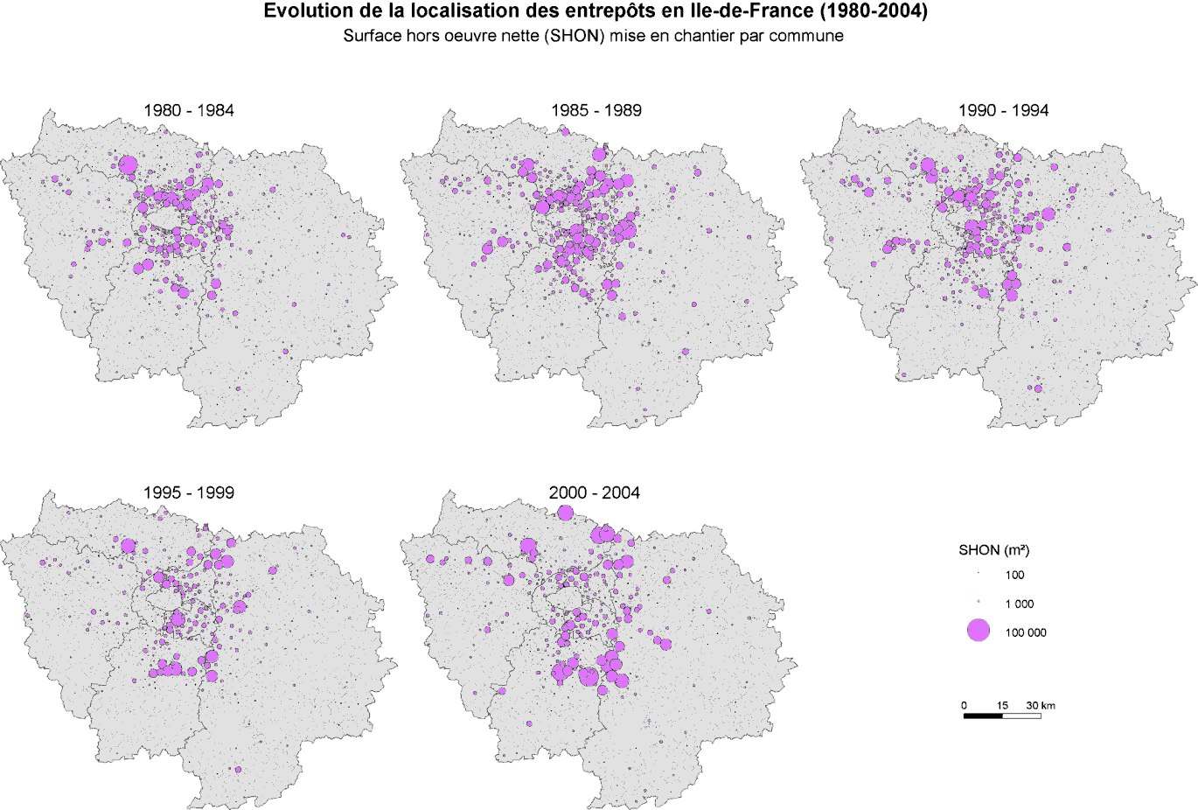
Source : Antoine Frémont INRETS

Main logistics developments in the Beijing metropolitan area

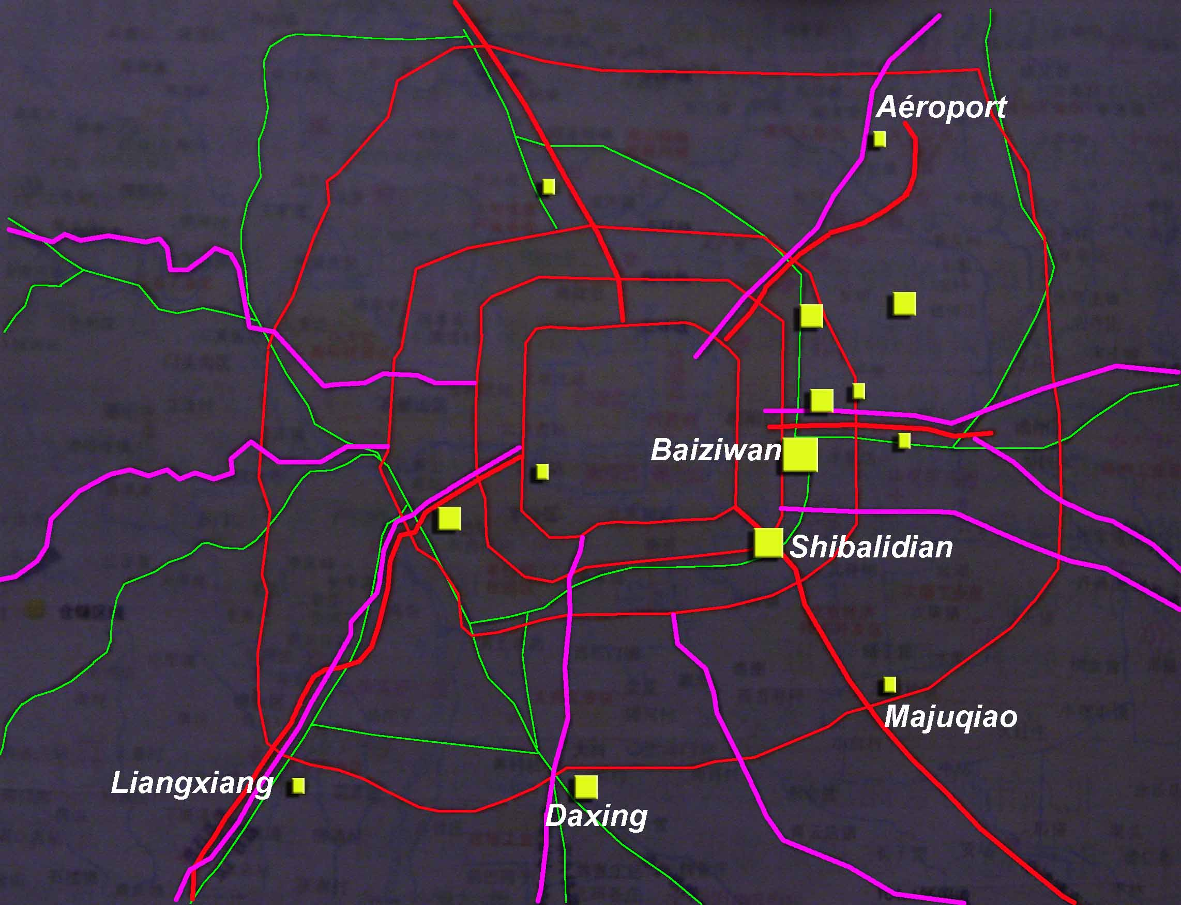
Source : Liu Xiaoming, La logistique de la région pékinoise, master thesis, Université de Paris-Est, 2007.

- Freight villages: functions and development

So as to find vacant space and to make their location easier, a growing proportion of logistics operations and facilities tend to gather in a specific type of zone, usually called "freight village" in English ("logistics centre" in the US, "plate-forme logistique" in French, "interporto" in Italian, "Güterverkehrszentrum" in German, "wuliu zhongxin" in Chinese, etc.).
A freight village is an industrial area mainly devoted to logistics activities. It can have been deliberately designed so, which is mostly the case now, or happen to be so de facto, when logistics activities occupy most of an industrial zone that had not necessarily been scheduled for such a specialisation. Such a site must fulfil several conditions, as it must be adequately located, properly designed and finally efficiently linked with infrastructure networks. If several types of infrastructure are available (rail and/or waterway in addition to road), the site is said to be "multimodal". But many sites are only served by road, particularly in Western Europe where this mode dominates inland transport.
A sophisticated know-how has been elaborated, considering planning, financing, engineering, operating and managing such facilities. Specialised professional bodies exist now, in charge of these various dimensions of freight villages. Both public and private sectors are involved in such projects, with different positions and roles. Public sector has a strong control of spatial planning and of regulation. It can also be directly active in developing a site (through an adequate structure such as a public capital company): purchasing the land, equipping it before selling it out to final investors. Private sector is divided in several professional layers, including developers, investors, operators, plus specialised consultants, architects, builders, equipment providers, facility managers, etc. In the following sketch, on a rising vertical axis, one goes from public to private actors and from a long lasting involvement to a more foot loose relationship with the territory: public authorities, once they decided the building of a freight village, will have to do with it indefinitely, whereas an investor can lay out his capital for a decade, getting a lease from the tenant operator for 3, 6 or 9 years according to French law, who himself commonly has a one year contract with his shipper customer.

Actors involved in a freight village project

All logistics activities are not likely to locate in such sites, if they are tightly linked with another site (e.g. a manufacturing plant) or have specific requirements (e.g. raw materials handled, stocked and carried in large quantities of bulk) and many of those remain in-house activities (they are not outsourced to 3PLO). Altogether, a growing proportion of locations occur inside freight villages. Consequently, a growing proportion of traffic is also emitted and received by such specialised areas.
Why such a polarisation? Locating logistics activities in an adequate place allows an access to available land, where logistics is accepted according to planning documents, where building permit and operation licence are delivered quicker. It also makes cooperation among transport and logistics service providers easier, up to "mutualisation" which to-day's buzzword in the business. When buildings (mainly warehouses) are leased, a certain flexibility of capacity is made possible (by exchanging slots between tenants). Gradually, a specialised labour market appears, easing the recruitment and adjustment of qualified staff (including sub-contracting and temporary work). Various establishments, depending on different firms, can share facilities and services (e.g. customs, safety control, surveillance, information services, etc.). Altogether, these advantages constitute "inside" external effects (within the site), that can be called effects of agglomeration, a freight village being a kind of industrial cluster. It also takes place inside the comprehensive local production system, supporting the activities of various "shippers" through the provision of adequate logistics services, and in return receiving activity from these various customers.

Acceptability of logistics by surrounding population and local governments is not as obvious as it used to be. Logistics is frequently associated with big and ugly buildings, hardly integrated into the landscape, and heavy road traffic with correlated nuisances. Although it is not true, logistics is also said to generate little employment and to pay little taxes to local and central governments. These acceptance issues probably show a gap between France and China, development remaining quicker and easier in the later county, but this gap may be temporary, the same problems generating the same reactions. To a large extent, freight villages can ease the acceptance of logistics, even inside an urbanised area. They are a dedicated zone (contrarily to the present tendency in urban planning to abolish strict zoning and to mix various activities, housing and public facilities). They are more or less isolated from surrounding population, with the help of adequate walls, trees or hills. They are directly linked with main infrastructure, avoiding mixing their traffic with local residential movements. They provide better security and safety for population as well as for stored goods, due to safer facilities, surveillance services, through a better controlled enforcement of regulation and with more efficient means to remedy problems. Polarising logistics activities concentrate nuisance in a limited area, avoiding a sprawl that would also be a sprawl of troubles touching a larger population. Altogether, freight villages thus reduce negative "outside" (surrounding the site) negative external effects.
Finally, the key issue for developers as well as for public planners and decision makers is to determine the proper trade-off between advantages and drawbacks of such facilities. The major argument supporting a freight village project, frequently sufficing to counterbalance all other problems, is the creation of jobs and, more generally, the contribution to regional development.

New concerns even strengthen the links between a freight village and its social, economic and political territory. Considering the manpower market, employers frequently complain about a risk of shortage in recruitment, of insufficient stability or qualification of manpower. The concentration of employers may, on the one hand, exhaust local resource, or fuel a rising competition among employers to attract employees. It may, on the other hand, structure individual and collective know-how that is transmitted from firm to firm and profits to the whole area. An adequate initial and professional training organisation, at various levels of qualification and in relationship with surrounding education institutions, is a key contribution to such a development, joining social and economic aims.
Passenger transport is another problem, as a long distance daily shuttle deters workers from going to remote working places if they have to bear the heavy cost of a private car. A freight village generates more traffic by private car to transport people than by lorry to carry freight! Grouping logistics firms in a single pole provides the necessary critical mass to set up public transit, adapted to specific working hours that are frequent in logistics. An appropriate housing policy, tightening the links between different dimensions of urban planning, is an important complementary topic.
The presence of a large number of firms and of jobs in the same site also makes it more attractive for employees, if they can find such useful daily services as a health centre, a multi-firm canteen, various shops, etc.

Freight villages are major points of emission, reception, transhipment of traffic. They are therefore key elements to consider in the framework of a transport policy, particularly in to-day's strategy for a more sustainable type of transport, consuming less energy and emitting less pollutants and green house effect gases. To limit the use of road haulage to short distance and to develop alternative, low energy consuming solutions (rail, waterway, intermodal transport), which all are heavy means requiring big size shipments to be efficient, the consolidation of freight is a necessity. Regrouping shippers and consignees in the same area gives consolidation better chances. In that case, the freight village is multimodal. Consequently, adequate sites, served by several types of infrastructure in proper technical conditions, must be preserved for logistics, against richer activities (offices, housing, etc.) that could overcome logistics in the competition for land and expel it from the city. Adequate urban planning is the condition for such a policy, setting mandatory functions for crucial nodes of the territory.

Freight villages are therefore anything but an exogenous object, merely imposed to a territory. Their design, implementation and acceptance are the result of an intense relationship between private and public sectors, economic and socio-political aims and rationales, logistics industry and territory, sometimes according to a formal negotiation (top-down and bottom-up) to elaborate satisfying trade-offs between pros and cons of such facilities. This relationship is still more necessary than before, due to new concerns about environmental and social issues that will accompany the village for its whole life duration, after the initial construction phase. Entire policies have yet, in a large extend, to be invented. As a whole, the need to gather logistics activities inside specific zones is stronger than ever, and freight villages become key topics for urban planning.
Freight villages, in spite of their diversity, do not provide an answer to all requirements of spatial development of logistics. Their main function is to operate massive long distance flows of goods (in harbours, airports, central distribution centres) and/or to link them with short distance collect and distribution. But they are necessarily large areas, so as to reach before-mentioned economies of scale and scope, and cannot therefore be inserted in the heart of urban and metropolitan areas (even in the case of vertical logistics buildings, which exist in Japan, Hong-Kong, etc.). They remain at the fringe of the core area or more far away. Complementary more intra-urban logistics facilities are therefore needed and have to be designed and achieved. Existing methods of urban logistics are widely analysed as very inefficient (through inadequate suboptimal facilities, a wide use of low productivity own-account transport, etc.) and new methods and equipments have to be set up, with a wide room for manoeuvre likely to diminish traffic and greenhouse gas emissions. Several types of facilities are explored, such as "logistics hotels" mixing light logistics (parcel service) with other activities sharing the land cost, integrating logistics deeper into urban economy. There is also a need for "logistics shops", smaller, corner-of-the-street facilities, together with relay service in other shops, automatic self-service lockers, etc. These fixed nodes of the urban network raise also the issue of the transport link between peripheral and central locations, in terms of type and size of vehicles, type of engine and energy. In terms of organisation, mutualisation of urban logistics services provides a wide field for experiment and progress. One must notice that these issues will grow in important, as consequences of new logistics methods and tools: e-commerce, vicinity retail, new services to population and economy.

- Comparison of Chinese and French experiences

Both contexts (China and France, more widely Western Europe) are very dissimilar, and are not themselves homogeneous either. Geography (in terms of density, distances…), institutions, planning process, rhythm and content of economic development and of logistics development are very different. Does comparison even make sense? We think so, considering that basic concepts are the same and are relevant in both situations, when the problem is to insert logistics into urban and regional planning and when the freight village comes out as a key representative object for planning and management.
Both contexts evolve at different rhythms but face comparable questions, such as the reluctance of some population and local government vis a vis logistics (preferring offices, shopping malls or high tech manufacturing to warehousing), the lack of land for such huge industrial parks that are freight villages, resulting in the tendency to expel logistics too far away from metropolitan area core. Chinese as well as French cities have to combine location policy and transport policy. This link is always difficult to implement, all the more so as several scales of territory and of political institutions to coordinate (from technical, management and political viewpoints): international, national, regional and urban scales interact. The following map shows that China and the European Union have about the same geographical size, but this is not enough to say they are alike…

China and European Union

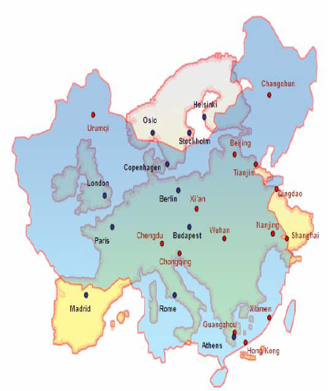

The notion of freight village appears in the French vocabulary of academic research, of State administration as well as of professional organisations as early as the 70': it is maybe a French invention (even if such configurations exist de facto since centuries: harbours, freight railway stations, etc.). This innovation coincides with a period of fast economic growth and of quick urbanisation, when zoning methods were popular among planners and when the growth of manufacturing industry took place with the help of the construction of "industrial parks". In this time, a freight village was a particular type of industrial park. In following years, the economic move shifted, aims of regional planning and of transport policy changed, but the notion of freight village went on receiving more interest although concerns also evolved.
Though, all attempts to elaborate a national master plan for logistics finally failed in France. There have been several schemes, reports and propositions to the government. None was really implemented as a comprehensive program, but several projects belonging to them were achieved, one by one (whereas the Italian plan for "interporti" was little by little finalised). Several reasons can be put forward to explain this fact. One is that, in a market driven economy, logistics mainly belongs to the private business realm, in spite of its strong (and ever stronger) social dimensions. The other one is political decentralisation, a main reform thought of during the 70' but effectively launched in France at the beginning of the 80' and giving broad responsibility to regions, provinces and cities concerning territorial planning. The central government cannot any longer impose his arbitrage, dealing with logistics as with other topics, and the fact that a freight village is often said to be "multimodal" is not enough to change this point. On the contrary, one observes number of schemes and implementations at local level. Regions and provinces have elaborated their own master plans for logistics, so as to promote new promising projects but also to avoid useless overlapping competing sites, and they frequently included them in the contracts they negotiated with the central government (according to a co-decision and co-financing process). Geography of logistics evolves and shows that these efforts receive substantial results, as dedicated areas are speeded up by the outsourcing tendency and group a growing proportion of logistics activities and of freight traffic.
China shows a more recent but quicker story. As everywhere else, logistics areas always existed but a special care for their development is recent. The typical first big operation was the Pinghu Shenzhen China Logistics Base, on a vast area of 1643 ha, in 1998. This first project was followed by many others, particularly in the most advanced coastal regions. The plan established under the responsibility of the National Development and Reform Commission, covering the 11th five year plan (2006-2010), mentions that special efforts must be made to develop modern logistics. Then, most provinces and big cities elaborate their own plans according to this national direction. More recently, the Adjustment of Modern Logistics Industry and Rejuvenation Plan (2009) set a nationwide list comprising 9 areas (not corresponding to administrative districts) pointed out as national logistics priorities, 21 big cities pointed out as national logistics nodes and 17 other cities as regional logistics nodes. Logistics is now an explicit topic for regional and urban planning.

Adjustment of Modern Logistics Industry and Rejuvenation Plan, 2009

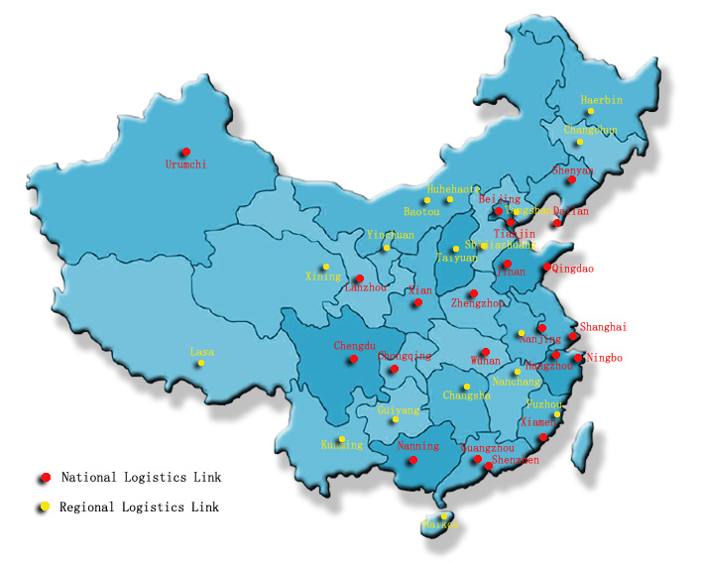

Comparison of Chinese and French sites shows conspicuous differences. Chinese freight villages generally cover vaster areas (measured in square kilometres, whereas French ones are measured in hundred hectares), they are often undertaken by State owned companies when in France development and investment mostly belong to private capital; they also include a non negligible proportion of manufacturing, rather than strictly logistics, activities. In spite of these differences, a resemblance can be observed concerning the dynamics of freight village development. Three main phases can be identified, which exist in both contexts:
- Initial growth phase: during a phase of rapid development of economic activity and of logistics, a sharp need of vacant space for expansion explains the construction of adequate sites (industrial parks, freight villages). Without yet belonging to a comprehensive policy, they benefit from the support of local authorities and possibly from public subsidies or involvement of public capital (to acquire the land and equip it before selling it out to private investors).
- Introduction of planning: a critical analysis of existing experiences is made. The first phase of quick spreading out results in useful constructions but also in several mistakes: badly designed equipments, empty sites responding to little demand, overcapacity or needless competition between nearby facilities, excessive sprawl away from city centres, difficult use of alternative transport modes, etc. Public authorities at higher level intervene to tidy up the situation. Planning appears as necessary, at various echelons of geographic scales and of political institutions. This all the more necessary as freight villages face a growing criticism among population and local elected representatives.
- Towards a sustainable urban logistics?: logistics is, in the same time, considered as more necessary than ever and as requiring more care in its development. It generates nuisances but also numerous workers' jobs that are not likely to be off-shored; it contributes to added value. It must also fit into a general policy aiming at diminishing fossil energy consumption and carbon oxide emission, and more generally to reduce negative external effects touching population. These issues are particularly sensitive in urban, densely inhabited, urban areas. Urban logistics is still archaic and is a vast field for innovation and progress. New methods of planning have to be invented, both top-down and bottom-up, so as to cope with environmental, economic and social dimensions of logistics development.
One notes that the dynamics of China and France enter this broad grid of analysis, but actual periods of this calendar do not coincide at all! Growth cycles have not been simultaneous, and are not today. Still, comparisons are possible, in both directions.

*

In spite of existing theoretical and practical work, the notion of freight village still has to be elaborated from a scientific viewpoint. It joins commonly separate fields that are economics and management on the one hand, spatial analysis and planning on the other hand. New concerns such as urban logistics, e-commerce, sustainable logistics, etc., require innovative solutions. Adequate methodologies still have to be elaborated, particularly through international comparison and cooperation. This topic is on the agenda of the Sino-French Centre for Urban and Regional Planning Studies that links Nanjing University and Paris-East University. It is a beautiful field for research and for more international understanding.

*

References

Ballis Athanasios, "Freight villages: Warehouse Design and Rail Link Aspects", Transportation Research Record: Journal of the Transportation Research Board, 2006, p 27-33.

China Federation of Logistics & Purchasing, China Society of Logistics, China Logistics Development Report(2008-2009), China Logistics Publishing House, 2009, 389p

China Federation of Logistics & Purchasing, China Society of Logistics, China Logistics Parks, China Logistics Publishing House, 2009, 306p

China Federation of Logistics & Purchasing, China Society of Logistics, China Logistics Academy Frontier Report (2006-2007), China Logistics Publishing House, 2006, p664

Kapros Seraphim, Panou Konstantinos, Tsamboulas Dimitrios A, "Multicriteria Approach to the Evaluation of Intermodal Freight Villages", Transportation Research Board, Volume 1906/2005, Transportation Research Board of the National Academies, p56-63

Liu Xiaoming, La logistique de la région pékinoise, master thesis, Université de Paris-Est, 2007.

Regan Amelia c., Golob Thomas F., "Trucking industry demand for urban shared use freight terminals", Transportation, (2005) 32, Springer, p 23-36

Savy Michel, "Production des transports, production de l'espace", in Régions et transport de marchandises, Coll.TRP, n° 86, La Documentation française, 1984.

Savy Michel, Logistique et territoire, Montpellier, GIP-Reclus, 1993.

Savy Michel, Logistique et territoire, La Documentation française, 2006.

Savy Michel, Le transport de marchandises, Éditions d'Organisation, 2006.

Savy Michel, Questions clefs pour le transport en Europe (dir.), La Documentation française, 2009.

Tsamboulas Dimitrios A, Kapros Seraphim, "Freight Village Evaluation Under Uncertainty With Public And Private Financing", Transport Policy, 2003, Elsevier, p 141-156

Tsamboulas Dimitrios, Dimitropoulos I., " Appraisal of Investments in European Nodal Centres for Goods - Freight Village: A Comparative Analysis", Transportation, Vol. 26, No.4, 1999, Kluwer Academic Publishers, p381-398

*

